Future Car Industry:

Recommendation for Kia Motors

Junseok Seo

Professor Buddy Levy

English 402

June 23 2014

Overview of the History of U.S. Automobile Industry

In the early years, U.S. automobile industry have started since 1895. Only four cars were officially registered in the U.S., but after few years, thousands of cars were registered because many car companies were founded and sold enormous number of cars, such as GM, Ford, Cadillac, Chevrolet, and other companies. Especially, Henry Ford, a legend car innovator, contributed in manufacturing process, business operational process and automobile technological advancement in the car industry. These innovations led to cost reductions in producing cars and decreased the automobile prices. Hence, many customers were able to afford cars more than ever before. After few decades, U.S. automobile industry faced a serious crisis during the depression years. Car sales decreased significantly and many car manufacturers had deficit. Most of companies fired countless employees. However, U.S. car industry had turned a surplus in post-World War II, and new technology, automatic transmission, was invented right after the war ended. Today, car sales have been increased and there are over millions of cars being sold. Despite the escalation of cars being sold, car industry continues to advance in business, technology, and manufacturing process. Even with the improved technologies of automobile, most car manufacturers are still focusing on producing petroleum cars in modern era (“How the U.S.,” n.d.).

Current Car Industry

Nowadays, car industry has been on the downfall. There are two possible reasons that influence the industry. First, economic recession in European Union, house bubble in U.S.A., and other causes are affecting our global economy and product consumptions. This rampant global recession is also striking all car manufacturers’ profit because many people are not willing to change their cars or buy new ones. Second reason that is reducing car consumption is the limitation of finite resources. Last few years the price of oil has increased severely, and the high oil price has influenced consumers to be more passive when purchasing cars. Of course, oil depletion affected the price even more because oil is the one of finite resources. In the article Les Magoon, an USGS geologist expects the depletion of oil will occur between 2003 and 2020 (Vidal, 2005). Oil depletion will be a definite possibility in the future, and the consumers need to be prepared before the depletion occurs.

Consequently, consumers want to purchase cars with high gas mileage or find new infinite resources consuming cars. According to the below chart, gasoline vehicle’s monthly sales have increased only .5 percent compared to monthly sales of gasoline cars from 2012. However, in 2013, electric vehicle’s monthly sales have increased by 71.6 percent from 2012’s monthly electric vehicle sales.

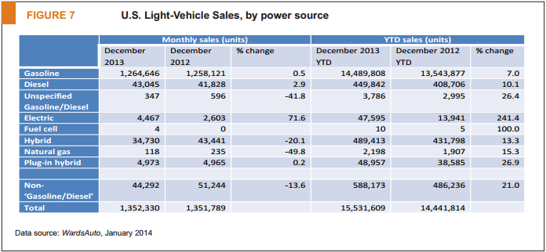

Source: www.nada.org

The electrical and hydrogen car industries have expanded as of only a few years ago. Before the 21st century, both types of cars were not able to perform as well as petroleum cars. They could only carry few people for limited miles and did not have efficient fuel storage. However, these problems have mostly been solved in the current time, and the cars will be efficiently utilized by many different places.

Electric and hydrogen car development is one of the valuable innovations in the car industry. These cars can reduce CO2 emission and save energy because usage of these cars occupies large portion of society transportation.

Nowadays, the automotive industry faces many different problems. Using eco-friendly cars save tons of fossil fuel, but many oil companies distract car manufactures from advancing in eco-friendly automotive field, as they fear losing income from their customers. Additionally, constructing hydrogen or electric charging stations cost thousands of dollar and many enterprise are not willing to build them. Even though there are many problems that have not been solved, one needs to be prepared when the resources reach its limitations. The need to develop cars that uses unlimited energy is urgent than ever before.

Electric Vehicles

With significantly improved electric vehicles, today’s automotive market offers variety of electric vehicles with diverse specification and performance. However, all electric vehicles have something in common, which is that they are operated by electricity. Consequently, the electric cars can be separated into different types by the fuel usage, but most electric cars are easily divided into two different models based on the electric supplying systems: Plug-in hybrid electric cars (PHEV) and battery electric cars (BEV). These two types of cars use electric power for operating their engines. The only difference between those two cars are plug-in hybrid electric vehicle utilizes both gas and electricity and battery electric vehicle uses only electricity. Here are brief overviews of these two types of cars.

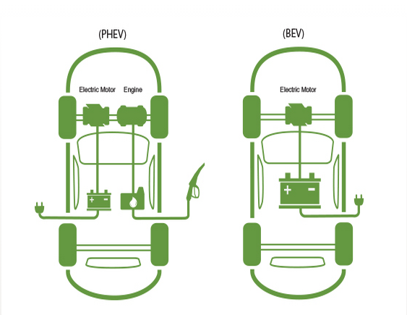

Source: www.sce.com

Plug-in hybrid electric vehicles are pretty similar to gas cars, however, the main difference is fuel use, electricity. The PHEV cars use the only gas for subsidizing electricity engine which extends mileage range. Dual-fuel engines are embedded in the car, so it enables to cars to use two different energies. The engine contains two different parts, an electric motor and an internal combustion engine, so people are able to drive the car by consuming both electricity and gas. Most plug-in hybrid electric cars’ run up to about 31 miles and the maximum speed is about 40 miles per hour (“Plug-in hybrid”, 2014). The internal engine will be used after consuming electricity. Every internal combustion engine has a different performance depending on how many cylinders the engine has, and every plug-in hybrid car has a different structure of how big the internal engine is. Most internal engine have the same functions as a general petroleum powered engine because it is also able to generate electricity.

One of the newest plug-in hybrid electric car is BMW I8. This car shows high performance among the current plug-in hybrid electric vehicles, and it shows how the technology has developed. Here is the specification from the BMW website.

|  |  |
| --- | --- |
| Engine Specification | |
| System output in kW (hp) | 266 kW (362 hp) |
| Electric motor: Output in kW | 96 kW |
| Electric motor: Max. torque in Nm | 250 Nm |
| Internal combustion engine: Cylinders/valves | 3 cylinders / 4 valves |
| Internal combustion engine: Capacity in ccm | 1,500 ccm |
| Internal combustion engine: max. output in kW (hp) at 1/min | 170 (231 hp) / 5,800 |
| Internal combustion engine: max. torque in Nm at 1/min | 320 / 3,700 |

|  |  |
| --- | --- |
| Range and Charge Time | |
| Electric range in km | 35 km |
| Maximum total range in km | Over 500km |
| Gross capacity of lithium-ion batter in kWh | 7.1 kWh |

|  |  |
| --- | --- |
| Performance | |
| Top speed fully electric in km/h | 120km/h |
| Top speed in km/h | 250 km/h |
| Acceleration from 0-60 km/h on purely electric power in seconds | 4.5 seconds |
| Acceleration from 0-100 km/h in seconds | 4.4 seconds |

Battery electric vehicles are only operated by electricity. They do not have any extra engines for subsidizing the electric motor, so they are able to fit a large lithium-ion battery inside. In other words, battery electric cars cannot run more than specific miles of range. Most electric vehicles have 80 to 100 miles of range because the battery has limited capacity of holding electrons (Berman, 2013). Therefore, drivers need to recharge their car when the battery is running out of electricity, and the car has to be plugged in to the electric power grid for several hours.

Tesla S model is one of the highly developed cars in U.S., and it represents how the technology has developed for battery electric vehicles. Here is the specification from the Tesla website.

|  |  |
| --- | --- |
| Tesla S performance model | |
| Battery power in kWh | 85kWh |
| Miles of range in miles | 300 miles |
| Maximum power in kW | 310 kW (416 hp) |
| Maximum Torque (Nm) | 443 lb torque (600 Nm) |
| Accerleration from 0-60 mph in seconds | 4.2 seconds |

Hydrogen Vehicle

Hydrogen vehicle is one of the best inventions, and it brings many advantages. As one might know, plenty of hydrogens exists on the Earth. We can find hydrogens easily on the air, and also from water, which contains hydrogen as well. If the car industry keeps innovating hydrogen vehicles, one will not need worry about depletion of finite fuels in the future.

When one looks inside of hydrogen cars, he or she will notice the cars are using an electric motor like electric vehicles. Additionally, their structure is also pretty similar to electric cars except only two parts: hydrogen storage tank and fuel cell stack. But why does it needs hydrogen? Here is the general structure of a hydrogen car.

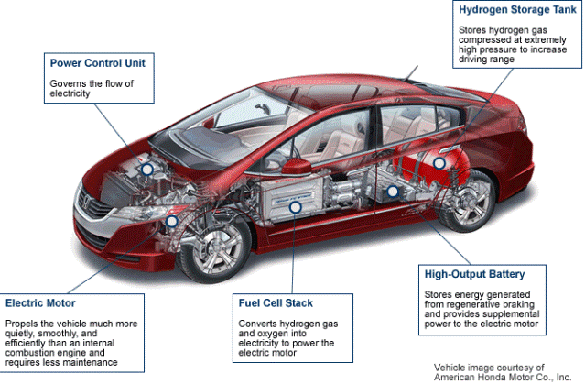

Source: www.utahcleancities.org

Let’s assume that one has a hydrogen car. Now, he or she is going to put some liquid hydrogen fuel in to a hydrogen car. The fuel goes to hydrogen storage tank directly. Then, the hydrogen gas will go to fuel cell stack. Fuel cell stack is the most important part in the hydrogen car because it will convert hydrogen gas and oxygen into electricity to power the electric motor (“Hydrogen Vehicles,” n.d.). During the electrolysis, water will be made and it will be emitted through tailpipe. Finally, the remaining electricity will be stored in the battery for future use. It is a better way to make electricity to power the engine instead of burning hydrogen in a combustion engine. Therefore, hydrogen cars should have basic structure of electric vehicles, electric motor and lithium-ion battery.

Before 2013, the consumers could not meet any hydrogen cars in the market. Car manufacturers were still developing the hydrogen cars and they only showed their hydrogen concept cars. In 2013, first production of hydrogen car hit the market, Hyundai ix35. Hyundai has planned to produce 1,000 ix35 fuel cell vehicles by 2015 (Howard, 2013). Hydrogen vehicle market has just started.

Here is the Hyundai ix35 hydrogen car’s specification from Hyundai website.

|  |  |
| --- | --- |
| Hyundai ix35 | |
| Power output in kW | 100 kW |
| Maximum power in hp | About 133 hp |
| Maximum torque in kg-m | 30.6 kg-m |
| Acceleration from 0-60 mph in seconds | 12.5 seconds |

Pros and Cons for Each Type of Car.

Both electric and hydrogen vehicles show great performance. However, each type of car has different strengths and weaknesses. The strengths and weaknesses show that electric and hydrogen vehicles have distinctive characteristics. Here are the pros and cons for a plug-in hybrid electric car, a battery electric car, and a hydrogen car.

Plug-In Hybrid Electric Vehicles Pros and Cons

Pros for using a plug-in hybrid electric vehicle

* Extend extra miles of range. Whenever the car runs out of electricity, the car will consume petroleum for operating the internal combustion engine. Therefore, the car will run few more miles than normal electric vehicles.
* Battery cost is lower than battery electric vehicles. Nowadays, lithium-ion is a rather expensive material because it can hold more electrons than any other materials. When the battery is bigger, then, the battery price increase significantly. Plug-in hybrid electric vehicles are using a smaller battery than battery electric vehicles, so plug-in hybrid cars can save more money when their batteries need to be changed.
* One can use gas only. If one’s car’s electric engine needs a service, then, he or she can use internal combustion engine until the electric engine will be fixed.

Cons for using a plug-in hybrid electric vehicle

* Emits carbon dioxide. Plug-in hybrid electric vehicles need to use gasoline for long run. Most cars can only run 31 miles of range with electricity, so they need to use the internal combustion engine when drivers are traveling more than 31 miles.
* Complexity. Plug-in hybrid electric vehicles requires more parts. As one might know, there are two different engines in a plug-in hybrid electric vehicle. Logically, this type of vehicle needs more parts for making two different engines than a single engine car.

Battery Electric Vehicles Pros and Cons

Here is the battery electric vehicles’ strengths

* Quiet and smooth. The electric engine for battery electric vehicles does not have any cylinders in the engine, so normal electric engine is more quite than a petroleum powered internal combustion engine (Berman, 2013).
* Home recharging. One can recharge your car easily at his or her place. One does not need to find and go to a recharging station. All he or she have to do is pull it into his or her garage, reach over for a plug, and just push it into the charging inlet (Berman, 2013).
* Cheaper to operate. Usually electricity is cheaper than gasoline. The cost per mile to fuel an electric vehicle is approximately one-third to one-quarter the cost of gasoline (Berman, 2013).

There are three weaknesses of battery electric vehicles.

* Limited range. Most electric cars only have about 80 to 100 miles of range because battery has limited capacity of electrons and one might not want to bring extra batteries for changing.
* Long refueling time. When one recharges his or her electric vehicle it takes times. If one wants to add about 20 to 25 miles of range, he or she needs to wait about an hour for charging 240 volts source of electricity. So if one has a 100 range electric vehicle then you need to wait four hours for full charge (Berman 2013).
* It needs higher cost. Current electric cars are mostly priced between 30 thousand dollars to 40 thousand dollars, Tesla S model is more than 60 thousand dollars. This makes electric vehicles considerably more expensive than comparably equipped small to midsized gasoline vehicles because they are mostly 20 thousand dollars or less.

Pros and cons Hydrogen vehicles

Hydrogen vehicles have unique pros.

* Eco friendly. Hydrogen cars make water for byproduct of electrolysis. Electric cars do not emit any carbon dioxide, as well as hydrogen cars.
* High efficiency. Theoretically, hydrogen release more energy than any other fuels because hydrogen has very high kinetic energy, so consuming hydrogen will provide high fuel economy. For instance, Hyundai ix35 shows very high efficiency. This model only needs 9.5 grams hydrogen requires to drive 1 kilometer.
* Unlimited resources. The earth has plenty of hydrogen. Hydrogen exists in the air and water is consist of hydrogen. One does not need to worry about the depletion of hydrogen

However, there are many cons for hydrogen vehicles

* High costs. Scientists are still figuring out how to store hydrogen. Hydrogen cannot be compressed well because it is one of the lightest elements in the Earth.
* Huge explosion. Hydrogen is the lightest element in the earth and also it is a highly flammable material in the earth too. So car collision may cause huge explosion. It could be more dangerous than an atomic bomb.
* Low performance. For proper performance a hydrogen car, there is the temperature restrictions. When a driver accelerate the car the hydrogen tank gets frozen because electrolysis drains energy from water liquefaction. Thus, Hydrogen cars cannot run more than specific speed.
* Infrastructure. Now, there are only few hydrogen gas stations around the world. More hydrogen gas stations needed to be founded in the future.

Porter’s Five Forces Model

Choosing a right industry is very important for company directors. Porter’s five forces model is a good tool for analyzing the industry. The five forces contains threat of new entrants, bargaining power of buyers, bargaining power of suppliers, threat of substitute, and rivalry in the market.

Electric Vehicle industry Analysis

* Threat of new entrants – moderate. In the electric vehicle industry, moderate threat of new entrants can be expected. Many car manufactures have started to develop electric vehicles recently and the market has not been saturated yet. Furthermore, Tesla Motors has opened their patents in this year, 2014 (Rooney, 2014). Anyone can use their technologies without restricted by the patent protection law. Therefore, there are still many chances for electric vehicle manufacturers.
* Bargaining power of buyers – moderate. The expected bargaining power of buyers are pretty moderate in the industry. A few electric vehicles have been produced for the last few years. In other words, there are only few choices for buying electric vehicles. However, switching cost is high. Price of electric vehicle is normally twice higher than mid-sized gasoline cars, so most consumers consider buying electric vehicles, compare to gasoline car consumers, and only few number of people bought electric cars. Therefore, the predicted bargaining power of buyers in the industry is moderate.
* Bargaining power of suppliers – low. The bargaining power of suppliers is low in the industry. Most materials for electric vehicles can be easily provided by many suppliers, and also the price of materials are usually inexpensive.
* Threat of substitute – High. Nowadays, there are thousands of cars available in the automotive market. Especially gasoline cars is dominate the car market and most car manufactures are trying to make high fuel efficiency cars. Additionally, the price of an electric car is twice higher than a normal gasoline car. Many consumers will be attracted by low price.
* Rivalry – moderate. There are only few electric vehicle manufactures. The number of electric vehicle companies keep increasing, however, rivalry in the market is expected moderate in these days.

Hydrogen Vehicle Industry Analysis

* Threat of new entrants – low. Many car companies have developed technologies for hydrogen vehicles but, only few cars have planned to be produced in the future. It is difficult to minimize a huge hydrogen tanks and a fuel cell stack. More infrastructures need to be established. There are only few number of hydrogen gas stations in U.S. Therefore, people would not want to purchase hydrogen cars until more hydrogen gas stations are built throughout each states.
* Bargaining power of buyers – low. Only one hydrogen car is available, Hyundai ix35. If a consumer want to buy a hydrogen car, the consumer does not have any choice instead of purchasing Hyundai ix35.
* Bargaining power of suppliers – moderate. Hydrogen car manufacturers need to get specific materials for manufacturing hydrogen storage tanks and fuel cell stacks. The materials are not too expensive, however, only suppliers are providing the materials because there is only one company that is producing the hydrogen cars in these days.
* Threat of substitute – high. Many substitutes are available in the car market. Consumers may consider to purchase a gasoline car or an electric vehicles instead of a hydrogen car. In the market, there is only one hydrogen car is available, so consumers will consider alternatives when purchasing cars.
* Rivalry – low. Many car companies are still developing technologies for making good hydrogen cars. Future rivalry can be expected high, however, there is only one car is available in the market now. Thus, rivalry for the hydrogen car industry is low now.

Recommendation

Both electric and hydrogen industries shows that they have potential possibilities for automotive companies that they can earn a huge profit in the near future. Here are two possible suggestions for Kia Motors. Frist, produce plug-in hybrid electric vehicles. Secondly, develop hydrogen vehicles for the future sales.

The best recommendation for Kia Motors is producing plug-in hybrid electric vehicles. Kia Motors have produced gasoline cars since 1957. They have know-how on building a good petroleum powered engine, so it will be easy to manufacture a plug-in hybrid electric vehicle than a battery electric vehicle. Developing a huge electric engine would be harder than developing a mid-sized dual fuel engine for plug-in hybrid electric cars. Moderate level of rivalry in the electric vehicle industry will create a great environment for Kia Motors. Kia Motors is going to compare their products to other companies’ products and supplement their products’ shortcomings. In addition, plug-in hybrid electric vehicle sales have increased gradually for the last three years. The below chart shows plug-in electric vehicle sales is about 20 thousand units, 40 thousand units, and 90 thousand units respectively in 2011, 2012, and 2013. From the chart, we can easily expect that more than 80 thousands of plug-in electric vehicle sales can be expected in 2014.

Therefore, getting into the plug-in hybrid electric market would be a great choice for Kia Motors.

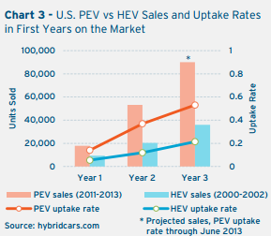

References

Berman, B., (2013, Oct 24). Electric Cars Pros and Cons [Web log]. Retrieved from <http://www.plugincars.com/electric-cars-pros-and-cons-128637.html>

Howard, B., (2013, Mar 7). Frist production hydrogen fuel cell cars hit the market, *ExtremeTech*. Retrieved June 23, 2014, from [http://www.extremetech.com/extreme/150202-first-production- hydrogen-fuel-cell-cars-hit-the-market-from-hyundai](http://www.extremetech.com/extreme/150202-first-production-%20%20%20%20%20%20%20%20%20%20%20hydrogen-fuel-cell-cars-hit-the-market-from-hyundai)

How The U.S. Automobile Industry Has Changed. (n.d.). *Investopedia*. Retrieved from <http://www.investopedia.com/articles/pf/12/auto-industry.asp>

Hydrogen Vehicles. (n.d.). *Utah Clean Cities*. Retrieved from <http://utahcleancities.org/hydrogen-vehicle>

National Automobile Dealers Association. (2013, Dec). *NADA Market Beat*. Retrieved from <http://www.nada.org/NR/rdonlyres/AAD0D79A-7C46-489F-B738-81F2E914BDD9/0/NADA_Market_Beat_2013_12.pdf>

Plug-in hybrid electric car (2014, Jan 15). *Sketchbook’s Diary* [Web log]. Retrieved from <http://humandrama.tistory.com/1079>

Rooney, J., (2014, June 20). Tesla has played the ‘open source’ card to good effect. *The Telegraph*. Retrieved from <http://www.telegraph.co.uk/technology/news/10913873/Tesla-has-played-the-open-source-card-to-good-effect.html>

State of the Plug-in Electric Vehicle Market. (2013, July 25). *Electrification Coalition*. Retrieved from <http://www.pwc.com/en_GX/gx/automotive/industry-publications-and-thought-leadership/assets/pwc-ec-state-of-pev-market-final.pdf>

Types of Electric Vehicles. (n.d.). *Tennessee Valley Authority*. Retrieved from <http://www.tva.gov/environment/technology/car_vehicles.htm#phev>

Vidal, J. (2005, April 21). The end of oil is closer than you think. *The Guardian*. Retrieved from <http://www.theguardian.com/science/2005/apr/21/oilandpetrol.news>

Tesla.

<http://worldwide.hyundai.com/WW/Showroom/Eco/ix35-Fuel-Cell/PIP/index.html>

<http://www.bmw.com/com/en/newvehicles/i/i8/2013/showroom/technical_data.html>

<https://www.sce.com/wps/portal/home/business/electric-cars/employees/!ut/p/b1/hc9NC4JAEAbg39LBY-7ohmm3FURX-7KidC-hYaugrpgl_fss6lCUzW2G5x1mEEMBYmV0yXjUZKKM8nvPtL2i28Sha6D6xraAmh4Y26XqEg93IOwA_CgC__I7xPqIPtM-gb0aq0DdrTVdmIoKI_UJDBssx110YONjoNiH-ZoQDPDa0HOkixjPRfx4OCRljHWOWJ0ckzqp5XPdjdOmqU4TCSRo21bmQvA8kQ-ikOBbJBWnBgXvElVFABkdsvjaDm7DcFSw/dl4/d5/L2dBISEvZ0FBIS9nQSEh/#image2>